Batch:D2 Roll No.: 16010221038

Name: Eshan Kalp Trivedi

Experiment / assignment / tutorial No. 2

Grade: AA / AB / BB / BC / CC / CD /DD

Signature of the Staff In-charge with date

**Title – Elastic and Inelastic Collision**

**CO1**

**Objective**

1. The Elastic and Inelastic collision simulation will help to analyse the collision variations for different situations.
2. Demonstration of collision behaviour for elastic and inelastic type.
3. Variation of collision behavior in elastic and inelastic type.
4. Study of variation of Momentum, Kinetic energy, Velocity of collision of the objects and the Center of Mass with different velocity and mass.
5. Calculation of the Momentum, Kinetic energy, and Velocity after collision.

**Theory**

**Collision**

The abrupt change in path of a moving body (or bodies) due to its interaction with other body (or bodies) is called collision. The magnitude and direction of the velocity of the colliding bodies may change in a collision. The force involved in collision acts only for a very short period of time. We come across many examples of collision daily. The coins of a carom game colliding with one another or collision between vehicles in road etc, are examples of collision. The Conservation Laws applied here are;

Law of Conservation of Linear Momentum: Total linear momentum of a system of a particle is conserved if there is no external force acting on the system.

i.e., Total linear momentum before collision is equal to total linear momentum after collision, if no external force acts on the system.

Law of Conservation of Energy: Energy can neither be created nor destroyed. But can be converted from one form of energy into another.

**Types of Collision:**

Elastic collision: The type of collision in which both the momentum and kinetic energy of the system are conserved is called elastic collision. The collision between subatomic particles is generally elastic. The collision between two steel or glass balls is nearly elastic. In elastic collisions, the forces involving are conservative in nature.

Inelastic collision: The type of collision in which only momentum is conserved, not kinetic energy is called inelastic collision. Most of the collisions in daily life are inelastic in nature.

**Formulas Used:**

In an elastic collision both kinetic energy and momentum are conserved. In the following equations, 1 and 2 indicate the two different objects colliding, unprimed variables indicates those before collision and primed variables indicate those after the collision, p is momentum, KE is kinetic energy, M is mass, and V is velocity.

Conservation of Momentum:

http://vlab.amrita.edu/userfiles/image001%282%29.png

 or

http://vlab.amrita.edu/userfiles/image003%282%29.png

http://vlab.amrita.edu/userfiles/image005%283%29.png

or

http://vlab.amrita.edu/userfiles/image007%282%29.png

http://vlab.amrita.edu/userfiles/image009%281%29.png

And

http://vlab.amrita.edu/userfiles/image011.png

http://vlab.amrita.edu/userfiles/image013.png

If the second object had a velocity V2 = 0 before the collision the equations become;

http://vlab.amrita.edu/userfiles/image015.png

And

http://vlab.amrita.edu/userfiles/image017.png

If the objects stick together after the collision the collision is a perfectly inelastic collision. In such a collision the velocities of the two objects after the collision are the same. Only momentum is conserved in the inelastic collision.

Conservation of Momentum:

http://vlab.amrita.edu/userfiles/image001%20%281%29.png

Or

http://vlab.amrita.edu/userfiles/image003%20%281%29.png

Since V2 = 0 and V'1 = V'2 the above solved for the velocities after the collision becomes;

http://vlab.amrita.edu/userfiles/image019.png

 Another approach is to combine elastic and inelastic collisions equations into one equation using the concept of the coefficient of restitution. The coefficient of restitution is defined by the relation;

http://vlab.amrita.edu/userfiles/image021.png

Where the coefficient of restitution for a perfectly elastic collision is e = 1 and for a perfectly inelastic collision is e = 0. The equation for the velocities after the collision becomes;

http://vlab.amrita.edu/userfiles/image023.png

And

http://vlab.amrita.edu/userfiles/image025.png

These two equations give the same results as obtained for the elastic collision if e=1 and for the inelastic collision if e=0.

**Setup Diagram:**

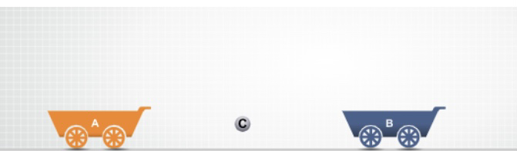

**PROCEDURE:**

Choose the type of collision (Elastic or Inelastic).The Coefficient of Restitution slider is fixed at 1 for Elastic collision. The mass and velocity of both the objects can be adjusted. The simulation will start on clicking the 'Play' button. The graphs like; Kinetic Energy verses Time, Velocity verses Time, Momentum verses Time, are shown for the objects depending upon the object movement. The velocity, momentum and kinetic energy after collision can be found out and crosschecked using the simulation.

**Free Body Diagram:**

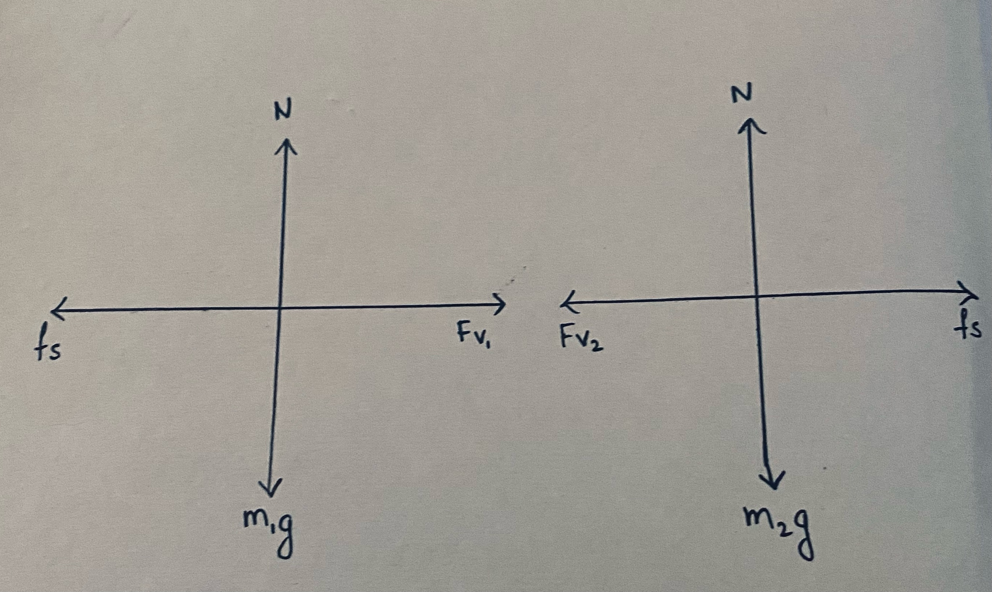

**OBSERVATION TABLE:**

|  |  |  |  |  |  |  |  |  |  |  |  |  |  |  |  |  |  |  |  |  |  |
| --- | --- | --- | --- | --- | --- | --- | --- | --- | --- | --- | --- | --- | --- | --- | --- | --- | --- | --- | --- | --- | --- |
| **S.N** | **m1** | **m2** | **e** | **Before Impact** | | | | | | **After Impact** | | | | | | | | | | | |
| **Experimental** | | | | | | **Analytical** | | | | | |
| **V1** | **KE1** | **P1** | **V2** | **KE2** | **P2** | **V´1** | **KE´1** | **P´1** | **V´2** | **KE´2** | **P´2** | **V´1** | **KE´1** | **P´1** | **V´2** | **KE´2** | **P´2** |
| **kg** | **kg** |  | **m/s** | **J** | **Kg.m/s** | **m/s** | **J** | **Kg.m/s** | **m/s** | **J** | **Kg.m/s** | **m/s** | **J** | **Kg.m/s** | **m/s** | **J** | **Kg.m/s** | **m/s** | **J** | **Kg.m/s** |
| 1 | 1 | 1 | 1 | 20 | 200 | 20 | -20 | 200 | -20 | -20 | 200 | -20 | 20 | 200 | 20 | -20 | 200 | -20 | 20 | 200 | 20 |
| 2 | 2 | 3 | 0 | 35 | 1225 | 70 | -25 | 937.5 | -75 | -1 | 1 | -2 | -1 | 1.5 | -3 | -1 | 1 | -2 | -1 | 1.5 | -3 |
| 3 | 4 | 2 | 0.7 | 30 | 1800 | 120 | 15 | 225 | 30 | 21.5 | 924.5 | 86 | 32 | 1024 | 64 | 21.5 | 924.5 | 86 | 32 | 1024 | 64 |
| 4 | 3 | 1 | 1 | 10 | 150 | 30 | -30 | 450 | -30 | -10 | 150 | -30 | 30 | 450 | 30 | -10 | 150 | -30 | 30 | 450 | 30 |
| 5 | 2 | 2 | 0 | 80 | 6400 | 160 | 20 | 400 | 40 | 50 | 2500 | 100 | 50 | 2500 | 100 | 50 | 2500 | 100 | 50 | 2500 | 100 |
| 6 | 3 | 5 | 0.7 | 50 | 3750 | 150 | 0 | 0 | 0 | -3.1 | 14.6 | -9.4 | 31.9 | 2540 | 159.4 | -3.1 | 14.6 | -9.4 | 31.9 | 2540 | 159.4 |

**SCREENSHOTS:**

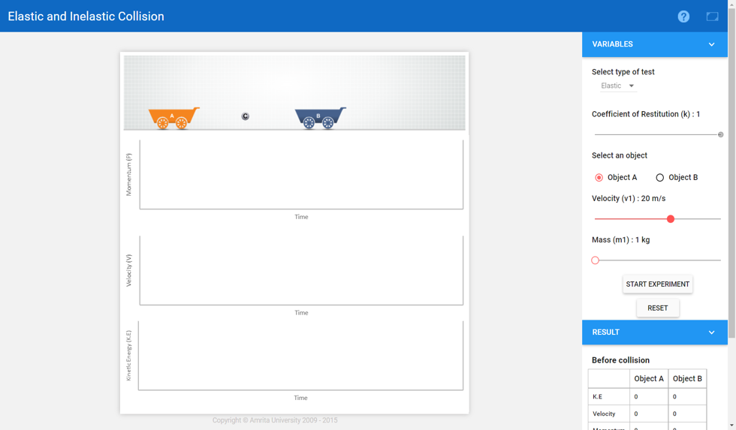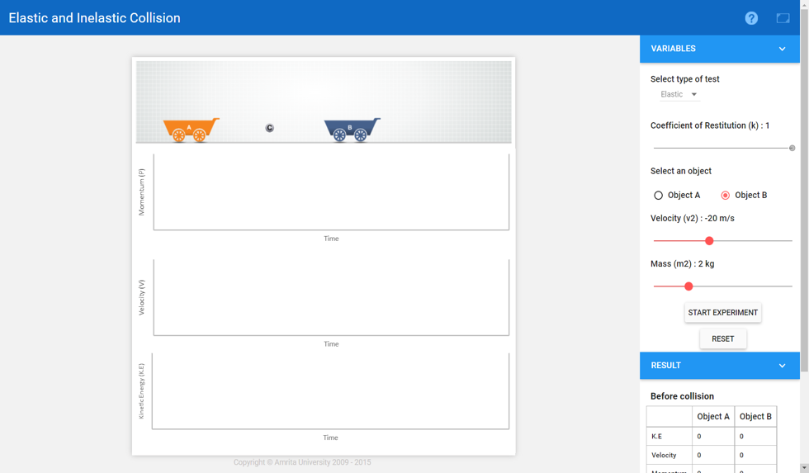

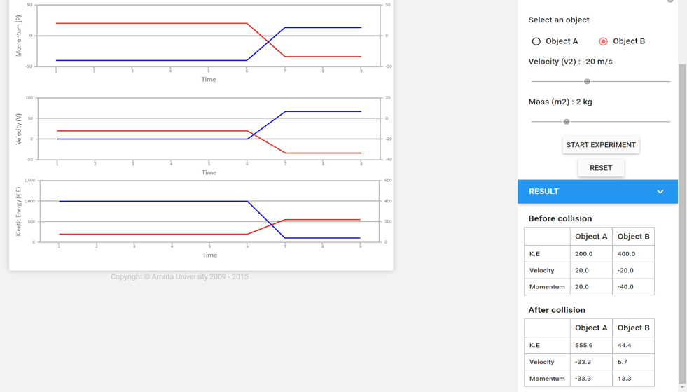

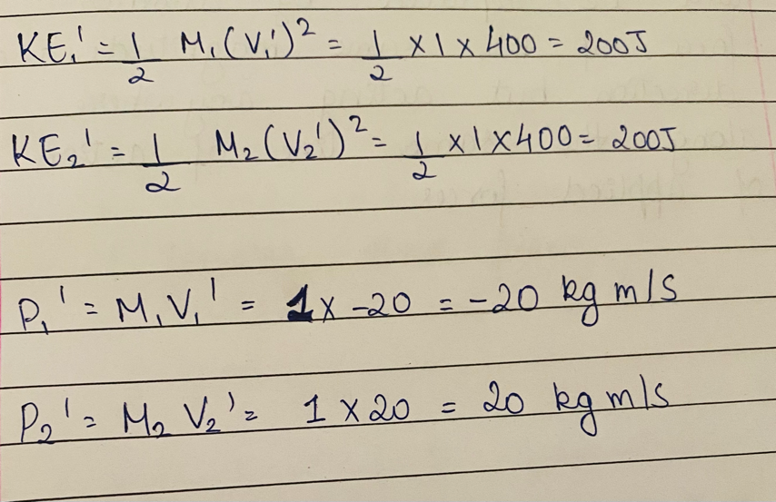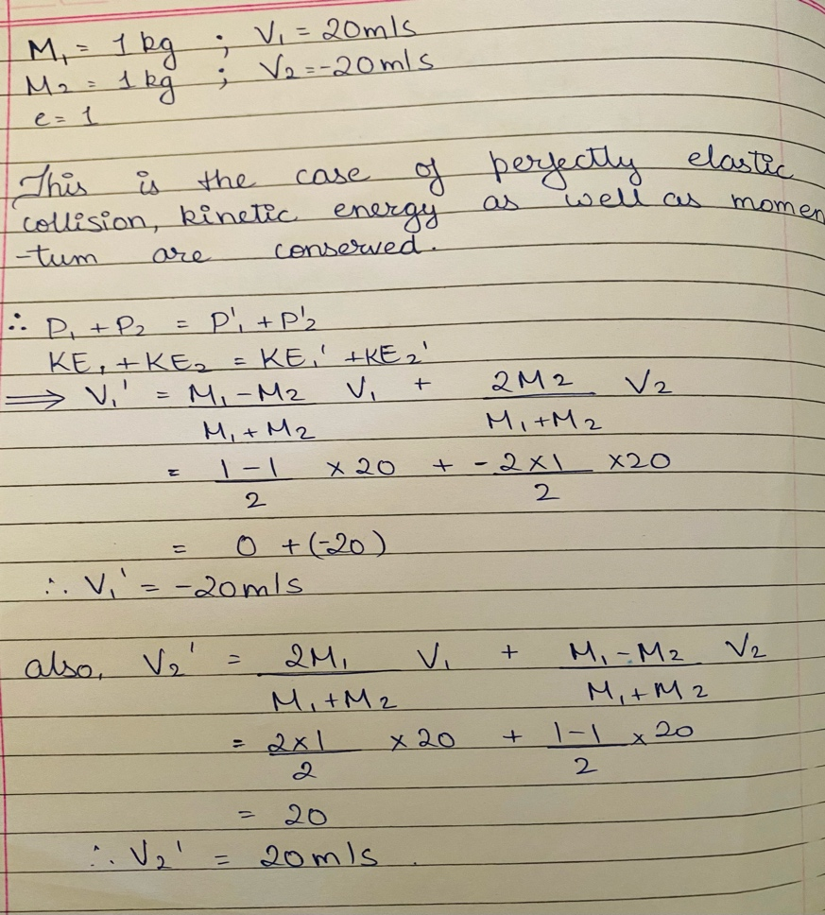**CALCULATIONS:**

**Conclusion:**  Successfully verified the conservation of momentum and kinetic energy in case of perfectly elastic collision and momentum in case of perfectly inelastic collision. Also, understood the variation of collision behaviours in elastic and inelastic types.

**Self-Evaluation:**

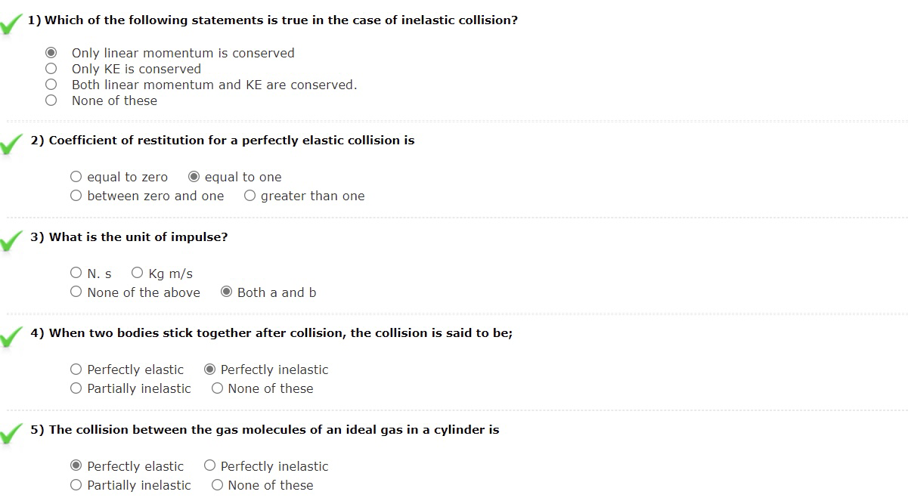

**Signature of faculty in-charge**

**Feedback**